Problem 4:

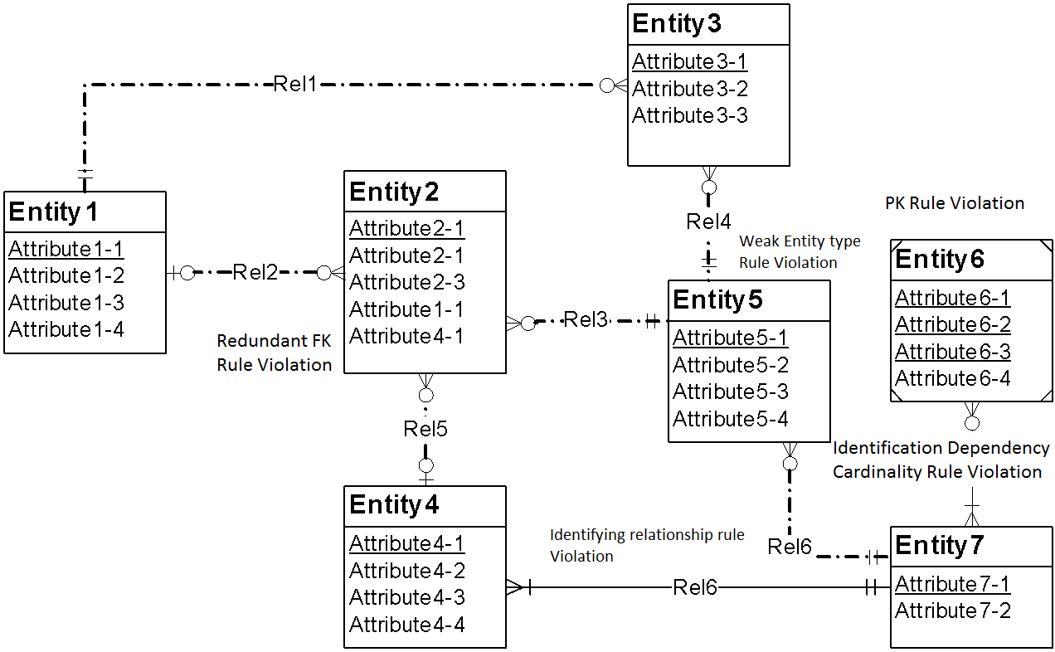

# Possible Resolutions:

**1) Resolution of the weak entity type rule:** The problem can be resolved by either adding one more identifying relationship or by changing the weak entity (Entity4) into a regular entity and making the relationship with Entity7 non-identifying.

**2) Resolution of the identifying relationship rule:** The problem can be resolved by adding one or more weak entities or making the relationship (Rel6) non-identifying.

**3) Resolution of the identification dependency cardinality rule:** The problem can be resolved by adding another entity to the identifying relationship.

**4) Resolution of the redundant FK rule:** Normally the problem can be resolved by removing the redundant foreign key (Entity2.Attribute4-1). If the attribute does not represent a foreign key, it should be renamed instead of removed.

**5) Resolution of primary key rule violation:** The problem can be resolved by specifying only one unique identifying attribute as primary key in Entity 6.